|  |  |
| --- | --- |
| **Blended/Flipped Classroom Request** | |
| 1. **Program Information** | |
| **Program Name:**  *.* | |
| **Program Type and Number (#):** ☐ Traditional Program:  *# .*  ☐ Home Care Aide Alternative “Bridge” Program:  *# .*  ☐ Medical Assistant Alternative “Bridge” Program:  *# .* | |
| **Program Director Name:**  *.* | **Date submitting request:**   *.* |
| 1. **Instructions** | |
| **Please complete and submit this application to be considered for ongoing approval to use a Blended format to teach classroom/theory content.**  **The Blended Flipped Classroom** contains in-person, classroom-based, synchronous instruction that incorporates elements of online learning, and technology-enhanced pedagogies. It is likely the most common and varied style of instruction. Outside instructional time occurs prior to meeting in person where concepts learned outside the classroom, prior to the class, are discussed or applied to instructor-led activities in the live classroom. | |
| 1. Select your **plan for using a variety of approaches** for presenting blended/flipped content   Select as many that will apply:   1. View Lectures 2. View Videos 3. Related Reading 4. Experiential Learning: Field Trip, Seminar 5. Online Assignments 6. Projects 7. Formative Assessments of Blended/Flipped Content 8. Submit a Common Curriculum application with a calendar that identifies the in-class and outside classroom hours and content. 9. See examples Appendix A and B: Unit 1 and Unit 5 10. See Appendix C: Common Curriculum Application with Calendar | |
| 1. **Provide your plan for evaluation** (how will knowledge be evaluated in this format?): *.* 2. Specifically, if not answered above, please indicate **how you will assure each student's identity in terms of testing** (i.e., testing integrity, doing one’s own work)?  *.* 3. **If you do not have software technology to assure students' identity for online testing**, then please check “Yes” here to attest you will implement testing (quizzes, exams) in person when students come for skills lab:   ☐ **Yes, I will give students all quizzes/tests in person when they come in for skills labs.** | |
| **Program Director Attestation and Signature** | |
| 1. **I attest that** **all the usual and required content will be delivered** **to students and that one (1) instructor shall teach no more than twenty (30) students at one time in a Blended/Flipped class.**   **Signature: __________________________________________** **Date:**  *.*  **Please print, sign, and return via email to:** [**WABONNursingAssistantsED@doh.wa.gov**](mailto:WABONNursingAssistantsED@doh.wa.gov) | |

**Appendix A: Sample Units 1 and 4**

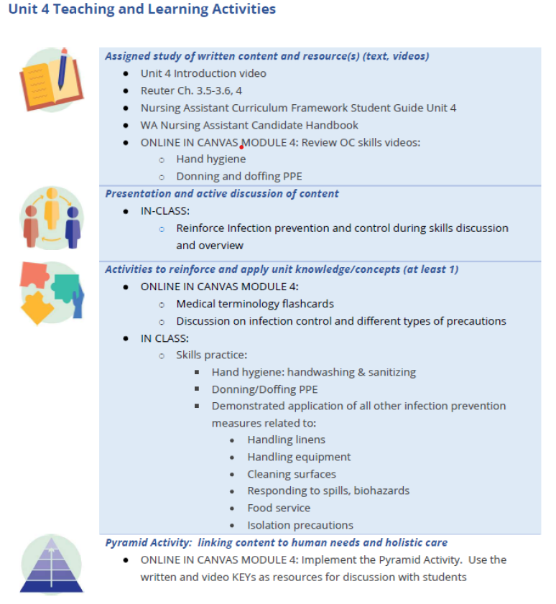

**Unit 4 continued on next page**

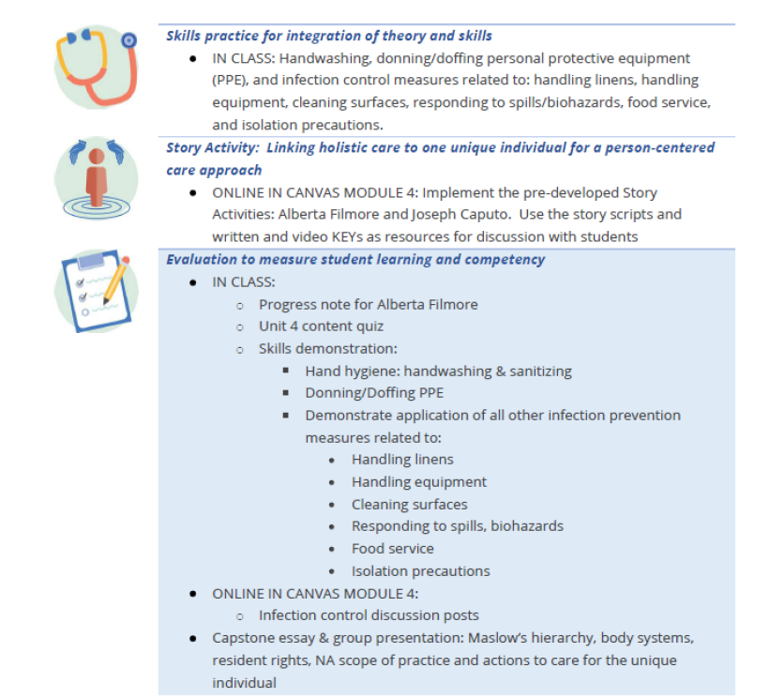

**Appendix B: Sample week 4 calendar**

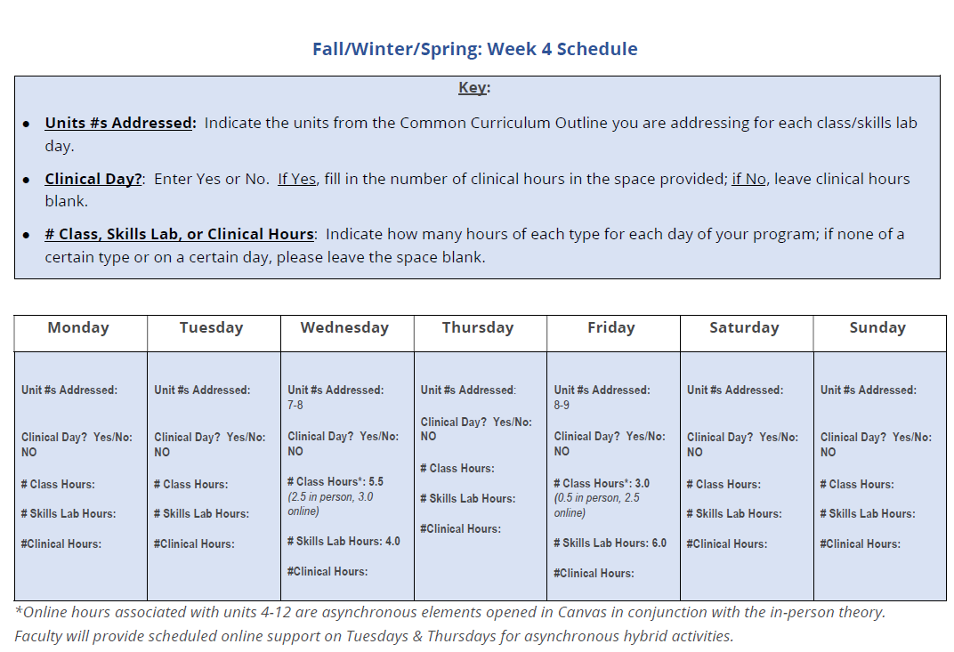

**Appendix C: Common Curriculum Application Unit 1 Teaching and Learning Activities**

|  |  |
| --- | --- |
|  | ***Assigned study of written content and resource(s) (text, videos)***   * Unit 1 Introduction videos; Resource Guide; and handout (“Maslow’s Hierarchy and the Nursing Assistant Process” ) |
|  | ***Presentation and active discussion of content***   * Present and discuss the three introduction videos for unit 1; review/discuss the Resource Guide and the Maslow handout |
|  | ***Activities to reinforce and apply unit knowledge/concepts (at least 1)*** |
|  | ***Pyramid Activity: linking content to human needs and holistic care***   * Implement the Pyramid Activity. Use the written and video keys as resources to lead students through the exercise. |
|  | ***Skills practice for integration of theory and skills***   * For unit 1, the Story Activity (listed below) fulfills skills practice |
|  | ***Story Activity: Linking holistic care to one unique individual for a person-centered care approach***   * Implement the Story Activity: Meet Alberta Filmore. Use the story scripts and the written and video KEYs as resources to lead students through the exercise |
|  | ***Evaluation to measure student learning and competency*** |

**Unit 2 Teaching and Learning Activities**

|  |  |
| --- | --- |
|  | ***Assigned study of written content and resource(s) (i.e., text, videos)***   * Unit 2 Introduction video |
|  | ***Presentation and active discussion of content*** |
|  | ***Activities to reinforce and apply unit knowledge/concepts (at least 1)*** |
|  | ***Pyramid Activity: linking content to human needs and holistic care***   * Implement the Pyramid Activity. Use the written and video KEYs as resources to lead the exercise with students |
|  | ***Skills practice for integration of theory and skills***   * For unit 2, the Pyramid and Story Activities fulfill skills practice. |
|  | ***Story Activity: Linking holistic care to one unique individual for a person-centered care approach***   * Implement the Story Activity: Alberta Filmore. Use the story script and the written and video KEYs as resources to lead the exercise with students |
|  | ***Evaluation to measure student learning and competency*** |

**Unit 3 Teaching and Learning Activities**

|  |  |
| --- | --- |
|  | ***Assigned study of written content and resource(s) (i.e., text, videos)***   * Unit 3 Introduction video |
|  | ***Presentation and active discussion of content*** |
|  | ***Activities to reinforce and apply unit knowledge/concepts*** |
|  | ***Pyramid Activity: linking content to human needs and holistic care***   * Implement Pyramid Activity. Use the written and video KEYs as resources to lead the exercise with students |
|  | ***Skills practice for integration of theory and skills***   * The Pyramid and Story Activities fulfill skills practice for unit 3. |
|  | ***Story Activity: Linking holistic care to one unique individual for a person-centered care approach***   * Implement the Story Activities: Joseph Caputo and Carol Montgomery. Use the story scripts and the written and video KEYs as resources to lead the exercise with students |
|  | ***Evaluation to measure student learning and competency*** |

**Unit 4 Teaching and Learning Activities**

|  |  |
| --- | --- |
|  | ***Assigned study of written content and resource(s) (text, videos)***   * Unit 4 Introduction video |
|  | ***Presentation and active discussion of content*** |
|  | ***Activities to reinforce and apply unit knowledge/concepts (at least 1)*** |
|  | ***Pyramid Activity: linking content to human needs and holistic care***   * Implement the Pyramid Activity. Use the written and video KEYs as resources for discussion with students |
|  | ***Skills practice for integration of theory and skills***   * Handwashing, donning/doffing personal protective equipment (PPE), and infection control measures related to: handling linens, handling equipment, cleaning surfaces, responding to spills/biohazards, food service, and isolation precautions. |
|  | ***Story Activity: Linking holistic care to one unique individual for a person-centered care approach***   * Implement the pre-developed Story Activities: Alberta Filmore and Joseph Caputo. Use the story scripts and written and video KEYs as resources for discussion with students |
|  | ***Evaluation to measure student learning and competency*** |

**Unit 5 Teaching and Learning Activities**

|  |  |
| --- | --- |
|  | ***Assigned study of written content and resource(s) (text, videos)***   * Unit 5 Introduction video |
|  | ***Presentation and active discussion of content*** |
|  | ***Activities to reinforce and apply unit knowledge/concepts*** |
|  | ***Pyramid Activity: linking content to human needs and holistic care***   * Implement the Pyramid Activity. Use the written and video KEYs as resources to lead the exercise with students. |
|  | ***Skills practice for integration of theory and skills***   * Use of proper body mechanics, turning and positioning clients or residents in bed and chair, transferring clients, assisting with ambulation, basic first aid measures (including the Heimlich maneuver), and CPR (for those who do not have a current CPR card) |
|  | ***Story Activity: Linking holistic care to one unique individual for a person-centered care approach***   * Implement the Story Activities: Carol Montgomery, Daniel Perez, and Mrs. Li. Use the story scripts and written and video KEYs as resources to lead the exercise with students. |
|  | ***Evaluation to measure student learning and competency*** |

**Unit 6 Teaching and Learning Activities**

|  |  |
| --- | --- |
|  | ***Assigned study of written content and resource(s) (text, videos)***   * Unit 6 Introduction video |
|  | ***Presentation and active discussion of content*** |
|  | ***Activities to reinforce and apply unit knowledge/concepts (at least 1)*** |
|  | ***Pyramid Activity: linking content to human needs and holistic care***   * Implement the Pyramid Activity. Use the written and video KEYs as resources for leading discussion with students |
|  | ***Skills practice for integration of theory and skills***   * Measuring and recording vital signs (blood pressure, pulse, respirations, temperature, and pain); measuring and recording oxygen saturation levels; working safely with oxygen; measuring and recording height and weight; and measuring and recording intake and output (fluid intake; urinary output; food intake; and bowel movements) |
|  | ***Story Activity: Linking holistic care to one unique individual for a person-centered care approach***   * Implement the Story Activities: Carol Montgomery, Daniel Perez, and Joseph Caputo. Use the story scripts and written and video KEYs as resources for leading discussions |
|  | ***Evaluation to measure student learning and competency*** |

**Unit 7 Teaching and Learning Activities**

|  |  |
| --- | --- |
|  | ***Assigned study of written content and resource(s) (text, videos)***   * Unit 7 Introduction video |
|  | ***Presentation and active discussion of content*** |
|  | ***Activities to reinforce and apply unit knowledge/concepts (at least 1)*** |
|  | ***Pyramid Activity: linking content to human needs and holistic care***   * Implement the Pyramid Activity. Use the written and video KEYs as resources for leading discussion with students |
|  | ***Skills practice for integration of theory and skills***   * Proper use of assistive devices in transfers, ambulation, eating, and dressing; transferring; assisting with ambulation; positioning and turning/re-positioning in bed and chair; passive range of motion of all joints; care and use of prosthetic/orthotic devices; and bowel and bladder training |
|  | ***Story Activity: Linking holistic care to one unique individual for a person-centered care approach***   * Implement the Story Activities: Joseph Caputo and Mrs. Li. Use the story scripts and written and video KEYs as resources for leading discussion |
|  | ***Evaluation to measure student learning and competency*** |

**Unit 8 Teaching and Learning Activities**

|  |  |
| --- | --- |
|  | ***Assigned study of written content and resource(s) (text, videos)***   * Unit 8 Introduction video |
|  | ***Presentation and active discussion of content*** |
|  | ***Activities to reinforce and apply unit knowledge/concepts (at least 1)*** |
|  | ***Pyramid Activity: linking content to human needs and holistic care***   * Implement the Pyramid Activity. Use the written and video KEYs as resources for leading discussion with students |
|  | ***Skills practice for integration of theory and skills***   * Assisting with bathing (assisting with/giving a bed bath, giving a back rub, assisting with showering); providing perineal care; providing catheter care; providing foot care; assisting with shampooing/hair care; assisting with shaving; assisting with dressing; applying elastic stockings; assisting with/providing mouth care; providing denture care; assisting with eating and drinking; assisting with elimination needs (bowel and bladder training; assisting with commode use, a bedpan, and urinal; emptying and managing urinary catheter drainage bags; and assisting to the bathroom) |
|  | ***Story Activity: Linking holistic care to one unique individual for a person-centered care approach***   * Implement the Story Activities (all characters). Use story scripts and written and video KEYs as resources for leading discussions |
|  | ***Evaluation to measure student learning and competency*** |

**Unit 9 Teaching and Learning Activities**

|  |  |
| --- | --- |
|  | ***Assigned study of written content and resource(s) (text, videos)***   * Unit 9 Introduction video |
|  | ***Presentation and active discussion of content*** |
|  | ***Activities to reinforce and apply unit knowledge/concepts (at least 1)*** |
|  | ***Pyramid Activity: linking content to human needs and holistic care***   * Implement the Pyramid Activity. Use the written and video KEYs as resources for discussion with students |
|  | ***Skills practice for integration of theory and skills***   * Post-mortem care |
|  | ***Story Activity: Linking holistic care to one unique individual for a person-centered care approach***   * Implement the Story Activities: Mrs. Li and Alberta Filmore. Use the story scripts and written and video KEYs as resources for discussion with students |
|  | ***Evaluation to measure student learning and competency*** |

**Part 1: Program Schedule for Common Curriculum Framework**

|  |
| --- |
| **General Program Information**  **Days of the week your program will run (Monday-Friday, Monday-Wednesday-Friday, Saturday and Sunday, etc.):**  **For Class/Skills Lab Days: Start Time:**   **End Time*:**  **For Clinical Days: Start Time:**  **End Time*:**  **\***If a program day is more than 4 hours long, then a 30 minute meal period should be included and not counted in the total program hours.  **Number of TOTAL Program Hours*:**   * **Number of CLASS/THEORY Hours*:** * **# of SKILLS LAB Hours*:** * **# of In-facility CLINICAL Hours*:**   **\***Please add your daily/weekly hours carefully for accurate totals in the spaces above and double-check them prior to submitting as calculation errors will delay review of the application. See [WAC 246-841A-440](https://app.leg.wa.gov/WAC/default.aspx?cite=246-841A-440&pdf=true) for minimum program hour requirements. |

**Directions:** Please provide the General Program Information requested below and then provide the program schedule information on a week-by-week basis, as indicated on the weekly calendar document that follows. Use as many weekly calendar templates as you need to reflect the schedule for your entire program cycle (for example, a 5-week program requires five weekly calendars). If you have more than one track (for example, a weekday-only option and a weekend-only option), please submit a complete calendar template for each

**Week 1 Schedule**

|  |
| --- |
| **Key:**   * **Units #s Addressed:** Indicate the units from the Common Curriculum Outline you are addressing for each class/skills lab day. * **Clinical Day?**: Enter Yes or No. If Yes, fill in the number of clinical hours in the space provided; if No, leave clinical hours blank. * **# Class, Skills Lab, or Clinical Hours**: Indicate how many hours of each type for each day of your program; if none of a certain type or on a certain day, please leave the space blank. |

|  |  |  |  |  |  |  |
| --- | --- | --- | --- | --- | --- | --- |
| **Monday** | **Tuesday** | **Wednesday** | **Thursday** | **Friday** | **Saturday** | **Sunday** |
| **Unit #s Addressed:**  **Clinical Day? Yes/No:**  **# Class Hours:**  **# Skills Lab Hours:**  **#Clinical Hours:** | **Unit #s Addressed:**  **Clinical Day? Yes/No:**  **# Class Hours:**  **# Skills Lab Hours:**  **#Clinical Hours:** | **Unit #s Addressed:**  **Clinical Day? Yes/No:**  **# Class Hours:**  **# Skills Lab Hours:**  **#Clinical Hours:** | **Unit #s Addressed:**  **Clinical Day? Yes/No:**  **# Class Hours:**  **# Skills Lab Hours:**  **#Clinical Hours:** | **Unit #s Addressed:**  **Clinical Day? Yes/No:**  **# Class Hours:**  **# Skills Lab Hours:**  **#Clinical Hours:** | **Unit #s Addressed:**  **Clinical Day? Yes/No:**  **# Class Hours:**  **# Skills Lab Hours:**  **#Clinical Hours:** | **Unit #s Addressed:**  **Clinical Day? Yes/No:**  **# Class Hours:**  **# Skills Lab Hours:**  **#Clinical Hours:** |

**Week 2 Schedule**

|  |
| --- |
| **Key:**   * **Units #s Addressed:** Indicate the units from the Common Curriculum Outline you are addressing for each class/skills lab day. * **Clinical Day?**: Enter Yes or No. If Yes, fill in the number of clinical hours in the space provided; if No, leave clinical hours blank. * **# Class, Skills Lab, or Clinical Hours**: Indicate how many hours of each type for each day of your program; if none of a certain type or on a certain day, please leave the space blank. |

|  |  |  |  |  |  |  |
| --- | --- | --- | --- | --- | --- | --- |
| **Monday** | **Tuesday** | **Wednesday** | **Thursday** | **Friday** | **Saturday** | **Sunday** |
| **Unit #s Addressed:**  **Clinical Day? Yes/No:**  **# Class Hours:**  **# Skills Lab Hours:**  **#Clinical Hours:** | **Unit #s Addressed:**  **Clinical Day? Yes/No:**  **# Class Hours:**  **# Skills Lab Hours:**  **#Clinical Hours:** | **Unit #s Addressed:**  **Clinical Day? Yes/No:**  **# Class Hours:**  **# Skills Lab Hours:**  **#Clinical Hours:** | **Unit #s Addressed:**  **Clinical Day? Yes/No:**  **# Class Hours:**  **# Skills Lab Hours:**  **#Clinical Hours:** | **Unit #s Addressed:**  **Clinical Day? Yes/No:**  **# Class Hours:**  **# Skills Lab Hours:**  **#Clinical Hours:** | **Unit #s Addressed:**  **Clinical Day? Yes/No:**  **# Class Hours:**  **# Skills Lab Hours:**  **#Clinical Hours:** | **Unit #s Addressed:**  **Clinical Day? Yes/No:**  **# Class Hours:**  **# Skills Lab Hours:**  **#Clinical Hours:** |

**Week 3 Schedule**

|  |
| --- |
| **Key:**   * **Units #s Addressed:** Indicate the units from the Common Curriculum Outline you are addressing for each class/skills lab day. * **Clinical Day?**: Enter Yes or No. If Yes, fill in the number of clinical hours in the space provided; if No, leave clinical hours blank. * **# Class, Skills Lab, or Clinical Hours**: Indicate how many hours of each type for each day of your program; if none of a certain type or on a certain day, please leave the space blank. |

|  |  |  |  |  |  |  |
| --- | --- | --- | --- | --- | --- | --- |
| **Monday** | **Tuesday** | **Wednesday** | **Thursday** | **Friday** | **Saturday** | **Sunday** |
| **Unit #s Addressed:**  **Clinical Day? Yes/No:**  **# Class Hours:**  **# Skills Lab Hours:**  **#Clinical Hours:** | **Unit #s Addressed:**  **Clinical Day? Yes/No:**  **# Class Hours:**  **# Skills Lab Hours:**  **#Clinical Hours:** | **Unit #s Addressed:**  **Clinical Day? Yes/No:**  **# Class Hours:**  **# Skills Lab Hours:**  **#Clinical Hours:** | **Unit #s Addressed:**  **Clinical Day? Yes/No:**  **# Class Hours:**  **# Skills Lab Hours:**  **#Clinical Hours:** | **Unit #s Addressed:**  **Clinical Day? Yes/No:**  **# Class Hours:**  **# Skills Lab Hours:**  **#Clinical Hours:** | **Unit #s Addressed:**  **Clinical Day? Yes/No:**  **# Class Hours:**  **# Skills Lab Hours:**  **#Clinical Hours:** | **Unit #s Addressed:**  **Clinical Day? Yes/No:**  **# Class Hours:**  **# Skills Lab Hours:**  **#Clinical Hours:** |

**Week 4 Schedule**

|  |
| --- |
| **Key:**   * **Units #s Addressed:** Indicate the units from the Common Curriculum Outline you are addressing for each class/skills lab day. * **Clinical Day?**: Enter Yes or No. If Yes, fill in the number of clinical hours in the space provided; if No, leave clinical hours blank. * **# Class, Skills Lab, or Clinical Hours**: Indicate how many hours of each type for each day of your program; if none of a certain type or on a certain day, please leave the space blank. |

|  |  |  |  |  |  |  |
| --- | --- | --- | --- | --- | --- | --- |
| **Monday** | **Tuesday** | **Wednesday** | **Thursday** | **Friday** | **Saturday** | **Sunday** |
| **Unit #s Addressed:**  **Clinical Day? Yes/No:**  **# Class Hours:**  **# Skills Lab Hours:**  **#Clinical Hours:** | **Unit #s Addressed:**  **Clinical Day? Yes/No:**  **# Class Hours:**  **# Skills Lab Hours:**  **#Clinical Hours:** | **Unit #s Addressed:**  **Clinical Day? Yes/No:**  **# Class Hours:**  **# Skills Lab Hours:**  **#Clinical Hours:** | **Unit #s Addressed:**  **Clinical Day? Yes/No:**  **# Class Hours:**  **# Skills Lab Hours:**  **#Clinical Hours:** | **Unit #s Addressed:**  **Clinical Day? Yes/No:**  **# Class Hours:**  **# Skills Lab Hours:**  **#Clinical Hours:** | **Unit #s Addressed:**  **Clinical Day? Yes/No:**  **# Class Hours:**  **# Skills Lab Hours:**  **#Clinical Hours:** | **Unit #s Addressed:**  **Clinical Day? Yes/No:**  **# Class Hours:**  **# Skills Lab Hours:**  **#Clinical Hours:** |

**Week 5 Schedule**

|  |
| --- |
| **Key:**   * **Units #s Addressed:** Indicate the units from the Common Curriculum Outline you are addressing for each class/skills lab day. * **Clinical Day?**: Enter Yes or No. If Yes, fill in the number of clinical hours in the space provided; if No, leave clinical hours blank. * **# Class, Skills Lab, or Clinical Hours**: Indicate how many hours of each type for each day of your program; if none of a certain type or on a certain day, please leave the space blank. |

|  |  |  |  |  |  |  |
| --- | --- | --- | --- | --- | --- | --- |
| **Monday** | **Tuesday** | **Wednesday** | **Thursday** | **Friday** | **Saturday** | **Sunday** |
| **Unit #s Addressed:**  **Clinical Day? Yes/No:**  **# Class Hours:**  **# Skills Lab Hours:**  **#Clinical Hours:** | **Unit #s Addressed:**  **Clinical Day? Yes/No:**  **# Class Hours:**  **# Skills Lab Hours:**  **#Clinical Hours:** | **Unit #s Addressed:**  **Clinical Day? Yes/No:**  **# Class Hours:**  **# Skills Lab Hours:**  **#Clinical Hours:** | **Unit #s Addressed:**  **Clinical Day? Yes/No:**  **# Class Hours:**  **# Skills Lab Hours:**  **#Clinical Hours:** | **Unit #s Addressed:**  **Clinical Day? Yes/No:**  **# Class Hours:**  **# Skills Lab Hours:**  **#Clinical Hours:** | **Unit #s Addressed:**  **Clinical Day? Yes/No:**  **# Class Hours:**  **# Skills Lab Hours:**  **#Clinical Hours:** | **Unit #s Addressed:**  **Clinical Day? Yes/No:**  **# Class Hours:**  **# Skills Lab Hours:**  **#Clinical Hours:** |

**Week 6 Schedule**

|  |
| --- |
| **Key:**   * **Units #s Addressed:** Indicate the units from the Common Curriculum Outline you are addressing for each class/skills lab day. * **Clinical Day?**: Enter Yes or No. If Yes, fill in the number of clinical hours in the space provided; if No, leave clinical hours blank. * **# Class, Skills Lab, or Clinical Hours**: Indicate how many hours of each type for each day of your program; if none of a certain type or on a certain day, please leave the space blank. |

|  |  |  |  |  |  |  |
| --- | --- | --- | --- | --- | --- | --- |
| **Monday** | **Tuesday** | **Wednesday** | **Thursday** | **Friday** | **Saturday** | **Sunday** |
| **Unit #s Addressed:**  **Clinical Day? Yes/No:**  **# Class Hours:**  **# Skills Lab Hours:**  **#Clinical Hours:** | **Unit #s Addressed:**  **Clinical Day? Yes/No:**  **# Class Hours:**  **# Skills Lab Hours:**  **#Clinical Hours:** | **Unit #s Addressed:**  **Clinical Day? Yes/No:**  **# Class Hours:**  **# Skills Lab Hours:**  **#Clinical Hours:** | **Unit #s Addressed:**  **Clinical Day? Yes/No:**  **# Class Hours:**  **# Skills Lab Hours:**  **#Clinical Hours:** | **Unit #s Addressed:**  **Clinical Day? Yes/No:**  **# Class Hours:**  **# Skills Lab Hours:**  **#Clinical Hours:** | **Unit #s Addressed:**  **Clinical Day? Yes/No:**  **# Class Hours:**  **# Skills Lab Hours:**  **#Clinical Hours:** | **Unit #s Addressed:**  **Clinical Day? Yes/No:**  **# Class Hours:**  **# Skills Lab Hours:**  **#Clinical Hours:** |

**Week 7 Schedule**

|  |
| --- |
| **Key:**   * **Units #s Addressed:** Indicate the units from the Common Curriculum Outline you are addressing for each class/skills lab day. * **Clinical Day?**: Enter Yes or No. If Yes, fill in the number of clinical hours in the space provided; if No, leave clinical hours blank. * **# Class, Skills Lab, or Clinical Hours**: Indicate how many hours of each type for each day of your program; if none of a certain type or on a certain day, please leave the space blank. |

|  |  |  |  |  |  |  |
| --- | --- | --- | --- | --- | --- | --- |
| **Monday** | **Tuesday** | **Wednesday** | **Thursday** | **Friday** | **Saturday** | **Sunday** |
| **Unit #s Addressed:**  **Clinical Day? Yes/No:**  **# Class Hours:**  **# Skills Lab Hours:**  **#Clinical Hours:** | **Unit #s Addressed:**  **Clinical Day? Yes/No:**  **# Class Hours:**  **# Skills Lab Hours:**  **#Clinical Hours:** | **Unit #s Addressed:**  **Clinical Day? Yes/No:**  **# Class Hours:**  **# Skills Lab Hours:**  **#Clinical Hours:** | **Unit #s Addressed:**  **Clinical Day? Yes/No:**  **# Class Hours:**  **# Skills Lab Hours:**  **#Clinical Hours:** | **Unit #s Addressed:**  **Clinical Day? Yes/No:**  **# Class Hours:**  **# Skills Lab Hours:**  **#Clinical Hours:** | **Unit #s Addressed:**  **Clinical Day? Yes/No:**  **# Class Hours:**  **# Skills Lab Hours:**  **#Clinical Hours:** | **Unit #s Addressed:**  **Clinical Day? Yes/No:**  **# Class Hours:**  **# Skills Lab Hours:**  **#Clinical Hours:** |

**Week 8 Schedule**

|  |
| --- |
| **Key:**   * **Units #s Addressed:** Indicate the units from the Common Curriculum Outline you are addressing for each class/skills lab day. * **Clinical Day?**: Enter Yes or No. If Yes, fill in the number of clinical hours in the space provided; if No, leave clinical hours blank. * **# Class, Skills Lab, or Clinical Hours**: Indicate how many hours of each type for each day of your program; if none of a certain type or on a certain day, please leave the space blank. |

|  |  |  |  |  |  |  |
| --- | --- | --- | --- | --- | --- | --- |
| **Monday** | **Tuesday** | **Wednesday** | **Thursday** | **Friday** | **Saturday** | **Sunday** |
| **Unit #s Addressed:**  **Clinical Day? Yes/No:**  **# Class Hours:**  **# Skills Lab Hours:**  **#Clinical Hours:** | **Unit #s Addressed:**  **Clinical Day? Yes/No:**  **# Class Hours:**  **# Skills Lab Hours:**  **#Clinical Hours:** | **Unit #s Addressed:**  **Clinical Day? Yes/No:**  **# Class Hours:**  **# Skills Lab Hours:**  **#Clinical Hours:** | **Unit #s Addressed:**  **Clinical Day? Yes/No:**  **# Class Hours:**  **# Skills Lab Hours:**  **#Clinical Hours:** | **Unit #s Addressed:**  **Clinical Day? Yes/No:**  **# Class Hours:**  **# Skills Lab Hours:**  **#Clinical Hours:** | **Unit #s Addressed:**  **Clinical Day? Yes/No:**  **# Class Hours:**  **# Skills Lab Hours:**  **#Clinical Hours:** | **Unit #s Addressed:**  **Clinical Day? Yes/No:**  **# Class Hours:**  **# Skills Lab Hours:**  **#Clinical Hours:** |

**Week 9 Schedule**

|  |
| --- |
| **Key:**   * **Units #s Addressed:** Indicate the units from the Common Curriculum Outline you are addressing for each class/skills lab day. * **Clinical Day?**: Enter Yes or No. If Yes, fill in the number of clinical hours in the space provided; if No, leave clinical hours blank. * **# Class, Skills Lab, or Clinical Hours**: Indicate how many hours of each type for each day of your program; if none of a certain type or on a certain day, please leave the space blank. |

|  |  |  |  |  |  |  |
| --- | --- | --- | --- | --- | --- | --- |
| **Monday** | **Tuesday** | **Wednesday** | **Thursday** | **Friday** | **Saturday** | **Sunday** |
| **Unit #s Addressed:**  **Clinical Day? Yes/No:**  **# Class Hours:**  **# Skills Lab Hours:**  **#Clinical Hours:** | **Unit #s Addressed:**  **Clinical Day? Yes/No:**  **# Class Hours:**  **# Skills Lab Hours:**  **#Clinical Hours:** | **Unit #s Addressed:**  **Clinical Day? Yes/No:**  **# Class Hours:**  **# Skills Lab Hours:**  **#Clinical Hours:** | **Unit #s Addressed:**  **Clinical Day? Yes/No:**  **# Class Hours:**  **# Skills Lab Hours:**  **#Clinical Hours:** | **Unit #s Addressed:**  **Clinical Day? Yes/No:**  **# Class Hours:**  **# Skills Lab Hours:**  **#Clinical Hours:** | **Unit #s Addressed:**  **Clinical Day? Yes/No:**  **# Class Hours:**  **# Skills Lab Hours:**  **#Clinical Hours:** | **Unit #s Addressed:**  **Clinical Day? Yes/No:**  **# Class Hours:**  **# Skills Lab Hours:**  **#Clinical Hours:** |

**Week 10 Schedule**

|  |
| --- |
| **Key:**   * **Units #s Addressed:** Indicate the units from the Common Curriculum Outline you are addressing for each class/skills lab day. * **Clinical Day?**: Enter Yes or No. If Yes, fill in the number of clinical hours in the space provided; if No, leave clinical hours blank. * **# Class, Skills Lab, or Clinical Hours**: Indicate how many hours of each type for each day of your program; if none of a certain type or on a certain day, please leave the space blank. |

|  |  |  |  |  |  |  |
| --- | --- | --- | --- | --- | --- | --- |
| **Monday** | **Tuesday** | **Wednesday** | **Thursday** | **Friday** | **Saturday** | **Sunday** |
| **Unit #s Addressed:**  **Clinical Day? Yes/No:**  **# Class Hours:**  **# Skills Lab Hours:**  **#Clinical Hours:** | **Unit #s Addressed:**  **Clinical Day? Yes/No:**  **# Class Hours:**  **# Skills Lab Hours:**  **#Clinical Hours:** | **Unit #s Addressed:**  **Clinical Day? Yes/No:**  **# Class Hours:**  **# Skills Lab Hours:**  **#Clinical Hours:** | **Unit #s Addressed:**  **Clinical Day? Yes/No:**  **# Class Hours:**  **# Skills Lab Hours:**  **#Clinical Hours:** | **Unit #s Addressed:**  **Clinical Day? Yes/No:**  **# Class Hours:**  **# Skills Lab Hours:**  **#Clinical Hours:** | **Unit #s Addressed:**  **Clinical Day? Yes/No:**  **# Class Hours:**  **# Skills Lab Hours:**  **#Clinical Hours:** | **Unit #s Addressed:**  **Clinical Day? Yes/No:**  **# Class Hours:**  **# Skills Lab Hours:**  **#Clinical Hours:** |