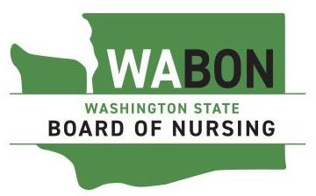

Approved Professional Vocational Relationships Courses
The following is a list of the Washington State Board of Nursing approved Professional Vocational Relationships (PVR) courses. A PVR course is required for RN nursing students approved to take the National Council Licensing Examination for Practical Nurses (NCLEX-PN) and for internationally educated nurses who are requesting approval to take the NCLEX-PN exam.

School | Contact
Grays Harbor College | Karen Carriker 360-538-4244  karen.carriker@ghc.edu
Lower Columbia College | Elizabeth Hoff  360-442-2602  ehoff@lowercolumbia.edu
Walla Walla Community College | Becky Manderscheid 509-527-4240  rebecca.manderscheid@wwcc.edu
Washington State University | Program Coordinator Nursing.profdev@wsu.edu 509-324-7332
Wenatchee Valley College | Imelda Barragan 509-682-6660  ibarragan@wvc.edu

