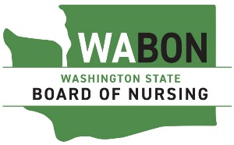

Washington State Board of Nursing
PO Box 47864 Olympia, WA 98504-7864

Registered Nurse (RN) Students

Taking NCLEX-PN

I certify the RN students listed below HAVE completed all requirements approved by the Washington State Board of Nursing in WAC 246-840-539 to take the NCLEX-PN. I further attest these students are capable to safely practice within the scope of a licensed practical nurse.

These students have completed the personal vocation relations (PVR) course either from Washington State University (WSU) confirmed by certificate, or our program’s commission approved PVR course.

The student has been instructed to request their official transcripts be sent to the Washington State Board of Nursing.

Last Name, First Name DOB

________________________________________________________

Name of Nursing Program Director

_________________________________________________________

School

Please send completed form to:

barbara.west@doh.wa.gov and amber.zawislak@doh.wa.gov
Washington State Board of Nursing

